**Class 5 learning objectives: Extensions of Mendelian Genetics:**

**By the end of this topic you should be able to:**

* **Define and give definitions of the different variations of Mendelian inheritance**

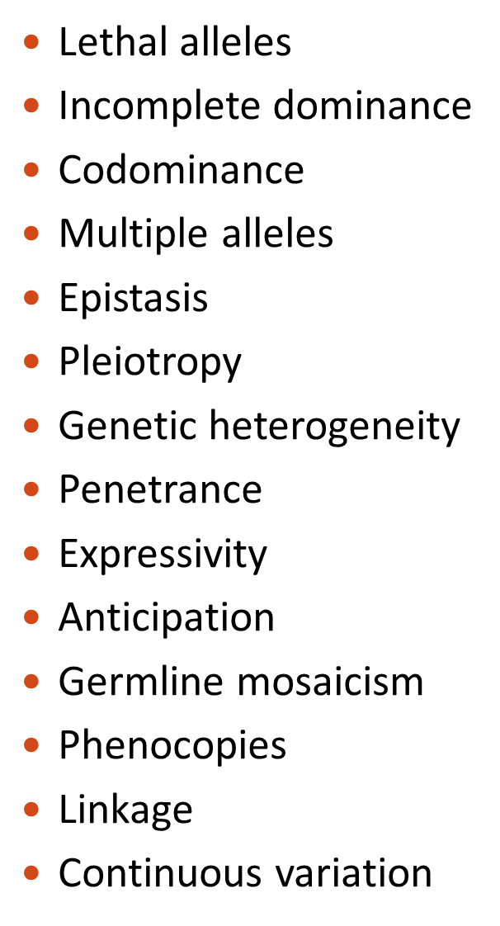

* **Contrast the phenotypic ratios of traits that exhibit incomplete dominance, co-dominance and lethal alleles with the expected Mendelian ratios.**

**For example: Lethal recessive alleles Manx cats**

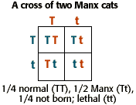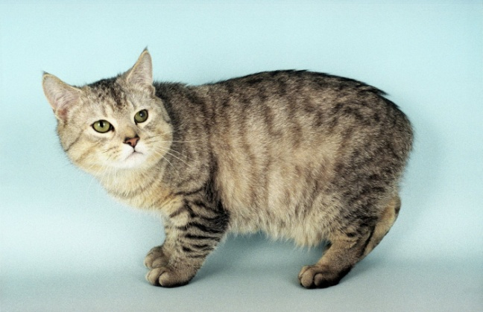

* **Describe the modes of inheritance of the ABO blood group system and make predictions about parentage based on the ABO blood group system.**

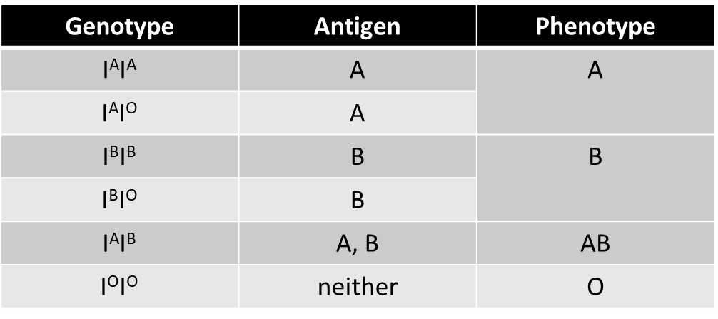

* **Explain the basis for the Bombay phenotype.**

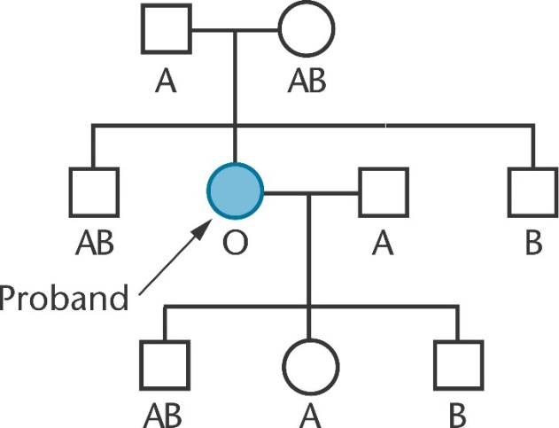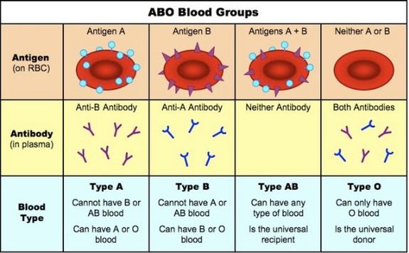

* **Explain how gene interactions (epistasis) can influence a particular characteristic**

**The alleles that are masking the effect are called epistatic alleles**

**The alleles whose effect is being altered or suppressed are called the hypostatic alleles**

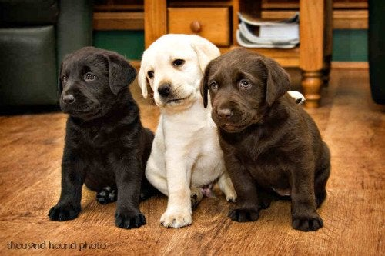 **Remember: epistasis occurs between different genes not alleles of the same gene.**

* **Apply your knowledge of how epistatic interactions effect Mendelian ratios of offspring to determine genotypes and phenotypes of parents.**

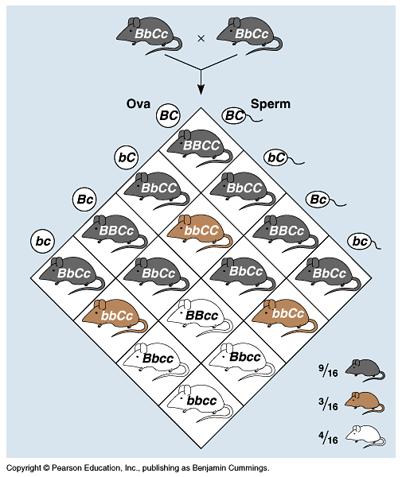

* **Define gene linkage and why linked genes on the same chromosome do not independently assort**

